**Advocacy**

**Addressing Microaggressions**

(Black text is the template, blue text is for your reference only)

**Title:** Addressing Microaggressions

## Description:

Microaggressions are subtle, often unintentional, forms of discrimination towards students of color and marginalized students. Although small and discrete, microaggressions can cause lasting harm on a student’s self esteem and mindset. Learn how to identify and help student’s address microaggressions to ensure their success.

Learning Objectives:

Upon completion of this module, you will be able to:

* Define the term microaggression
* Identify microaggressions that occur in tutoring settings
* Apply equity-centered strategies to help students address microaggressions

## Tutor’s Experience Level:

How would you describe your tutoring experience and skills?

Beginner tutor- 1 (no experience)

Expert tutor- 5

## Scenario 1:

Before we get started, please answer the following questions to help assess your existing knowledge. 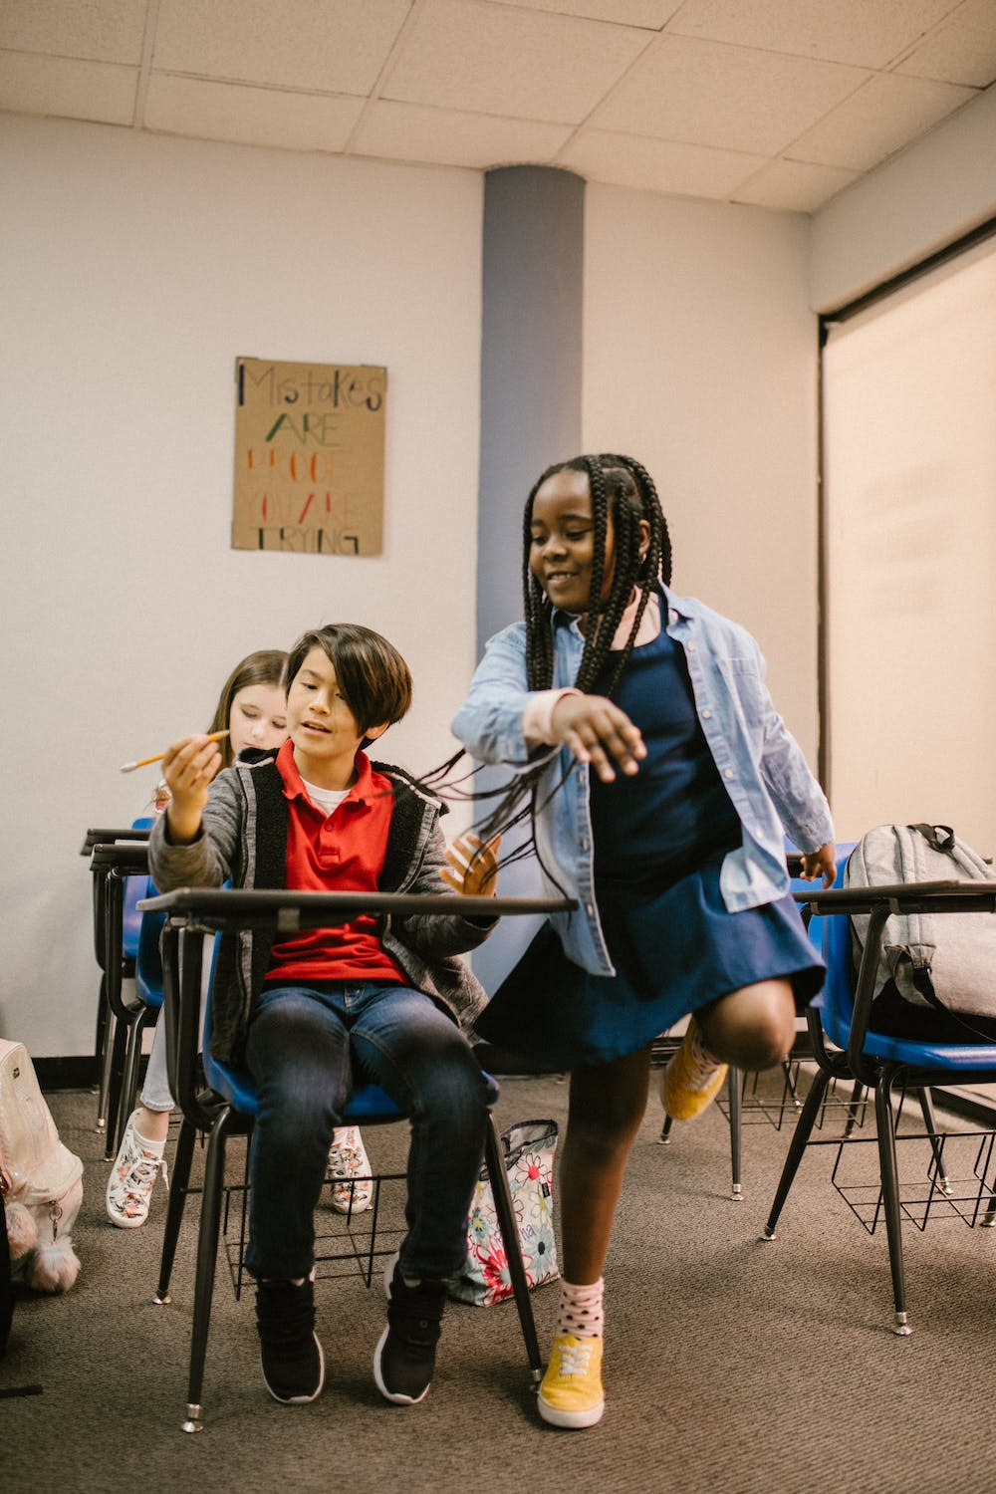

You are supporting a local elementary school as a tutor during the school day. You are waiting near the open door of a classroom to pick up Nori, a student you are pulling out of class to tutor. You hear Nori’s teacher say to her, “don’t worry about submitting your exit ticket, I know the problem is too difficult for you to complete.” As the student walks to meet you at the door, you notice a disappointed look on Nori’s face.

[[image link](https://www.pexels.com/photo/bullying-inside-a-classroom-6936166/)]

[Predict/Decide- Open Response, asking them to predict or decide what is the recommended tutor response in this situation]

1. What exactly would you say OR how exactly would you respond in order to acknowledge the microaggression that Nori just experienced?

[Predict/Decide - MCQ]

2. Which of the following strategies below do you think would best support acknowledging the microaggression that Nori just experienced?

I would say to the student:

1. “Nori, don’t mind your teacher, she is mean! I once had a teacher like her when I was in elementary school, no one liked her.”
2. “Nori, let’s look at the exit ticket during our session, I bet you can solve the problem!”
3. “Hi Nori, why the sad look on your face? We are going to have so much fun during our tutoring session today!”
4. “Nori, I noticed what the teacher just said to you may have hurt your feelings. Would you like to talk about it?

[Explain- Open]

3. Why do you think the approach you selected in the previous question will acknowledge the microaggression the student just experienced?

[Explain- MCQ)

4. Which of the following statements aligns with the rationale you chose and explained in the previous two questions.

1. Empathizing with the student is a great way to show you care. In addition, sharing similar situations that you experienced helps students deal with microaggressions.
2. Giving the student the opportunity to solve the problem during the tutoring session will help the student feel more confident.
3. Asking the student to share how she is feeling will create opportunities for authentic relationship building.
4. Acknowledging the student’s feelings and naming the microaggression, the teacher’s comment, will provide an opportunity to address the microaggression.

[Observe] - (Give desired, recommended response, according to research with explanation)

## Research Recommendation(s), Research says…

A *microaggression* is defined as verbal, behavioral, or environmental embarrassment that sends hostile and hurtful messages to people of color (Hammond, 2015). When teachers perceive students negatively due to their academic performance, as shown in the example, the microaggression impacts students’ perceptions of themselves and their abilities. Therefore, the correct or most desirable option is:

D. “Nori, I noticed what the teacher just said to you may have hurt your feelings. Would you like to talk about it?”

The above strategy seeks to acknowledge the microaggression and harmful actions of the teacher. This response invites the student to share how she is feeling so that the student is able to process and respond to the incident. If the tutor feels empowered to advocate for the student a separate conversation with the teacher may also be appropriate. It is important to address microaggressions and hold each other accountable for their actions.



[Explain- Open]

5. In your own words, please explain why it is important to be aware of how microaggressions impact student learning?

The chart below provides some common themes among types of microaggressions and how they show up in everyday life.

| Theme | Microaggression | Message |
| --- | --- | --- |
| Acknowledgment of Intelligence | *“You are so articulate and well spoken.”*  Asking an Asian person to help with a Math or Science problem. | It is unusual for someone of your race to be intelligent.  All Asian students are good at Math and Science. |
| Color Blindness | *“When I look at you, I do not see color.”*  *“There is only one race, the human race.”* | Denying a person of color’s racial expression.  Assuming the dominant culture is the only culture. |
| Myth of Meritocracy | *“I believe the most qualified person should get the job.”*  *“Everyone can succeed in this society, if they work hard enough.”* | People of color are given unfair benefits because of their race.  ~~People of color are lazy and need to work harder.~~ |

*Adapted from: Wing, Capodilupo, Torino, Bucceri, Holder, Nadal, Esquilin (2007). Racial Microaggressions in Everyday Life: Implications for Clinical Practice. American Psychologist, 62, 4, 271-286*

6. How much do you agree or disagree with the expert belief of the impact of microaggressions on student learning experiences?

Strongly disagree-1

Somewhat disagree-2

No opinion-3

Somewhat agree-4

Strongly agree-5

7. Explain why you agree or disagree.

[Explain- Multiple Choice]

8. Which statement is an example of a microaggression? Saying to the student,

A. “Nori, you speak so proper!”

B.”Nori, you are great at fractions!”

C.”Nori, tell me more about your neighborhood.”

D. “Nori, what is your favorite subject in school?”

## Research Recommendation

Microaggressions can occur when teachers or tutors misinterpret differences in culture as deficits in students ways knowing and being (Hammond, 2015). This harmful practice can have lasting impact on the students and how they perceive themselves and their ability in academic settings. Therefore, the correct answer to (8) is below:

1. “Nori, you speak so proper!”

## Scenario 2: [Same as pre-instruction]

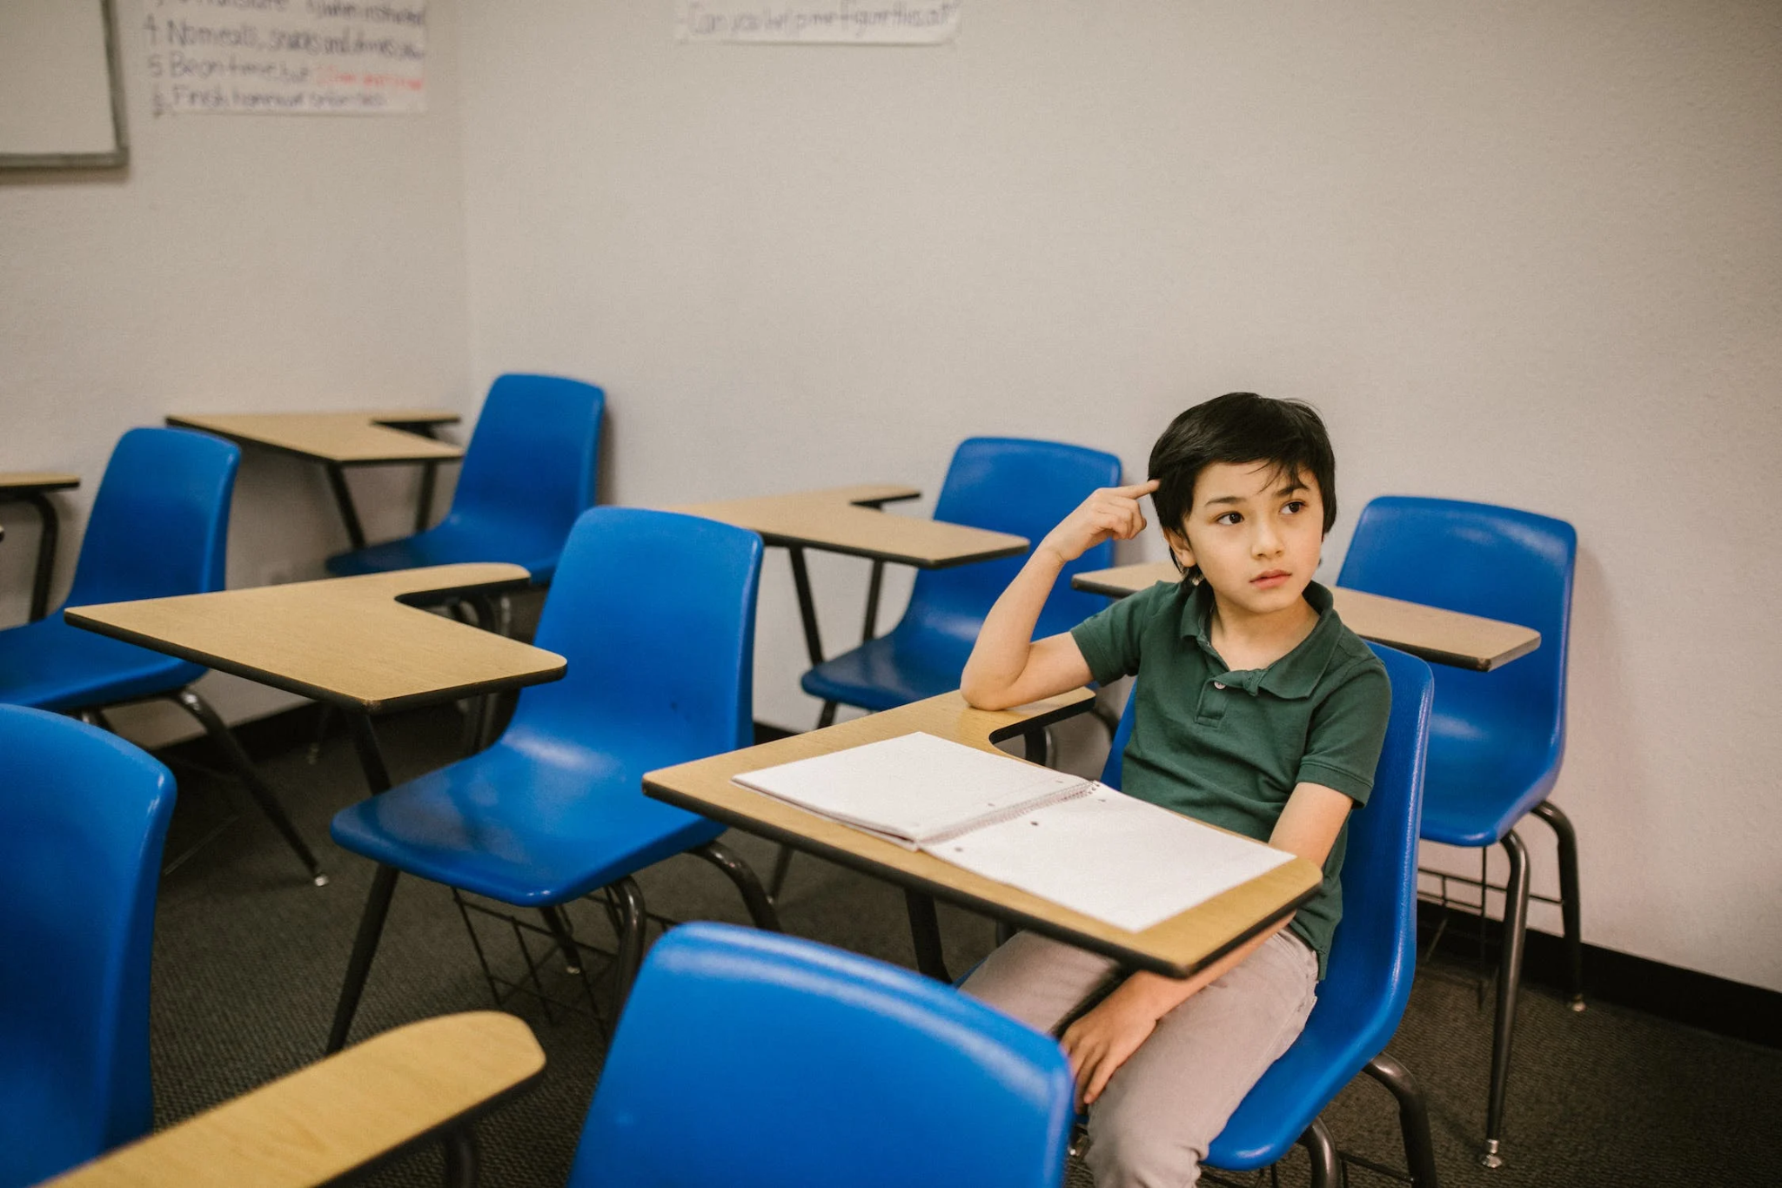

You are a math tutor working with a group of fourth graders. You begin the session by putting the students into groups of two, but one student, Ashley, states loudly, “I don’t want to work with Omar because he takes forever to finish assignments.” The other students continue working in their small groups unphased by Ashley’s outburst, but you notice Omar’s face looks completely defeated.

[[photo image](https://www.pexels.com/photo/boy-sitting-on-his-desk-looking-lonely-6936380/)]

[Predict/Decide- Open Response, asking them to predict or decide what is the recommended tutor response in this situation]

9. What exactly would you say OR how exactly would you respond in order to address the microaggression Omar just experienced?

[Predict/Decide - MCQ]

10. Which of the following strategies below do you think would best address the microaggression Omar just experienced? I would say to the student:

1. “Omar, when I was in school I struggled with math too, but I kept trying and practicing. Let me show you some strategies that helped me remember the order of operations.”
2. “Ashley, how would you feel if someone said that to you?”
3. “Ashley, that is not how we support each other in this tutoring program. Please apologize to Omar.”
4. “Omar, you can work with me and Ashley will work by herself.”

[Explain- Open]

11. Why do you think the approach you selected in the previous question will address the microaggression Omar just experienced?

[Explain- MCQ)

12. Which of the following statements aligns with the rationale you chose and explained in the previous two questions.

[Explain one correct (or most desired) option rationale and three incorrect (or less desired) responses being sure to capture common errors and misconceptions among tutors.]

1. Providing the student with math strategies will help him complete his assignments more quickly.
2. Making Ashley aware of her microaggression will prevent her from doing it again in the future.
3. Addressing Ashley’s microaggression holds her accountable for her actions and maintains a culture of mutual respect.
4. Separating the students will alleviate tension and allow the students to finish their assignments independently.

## Conclusion

The ability to understand what a microaggression is will provide tutors with skills to identify and address microaggressions that occur during tutoring sessions. Additionally, awareness of how microaggressions show up in everyday life may serve to prevent tutors from causing harm by enacting this behavior while working with students. Therefore, the correct or most desirable response to question 10 is below.

C. “Ashley, that is not how we support each other in this learning community. Please apologize to Omar.”

The above strategy seeks to acknowledge the microaggression and harmful actions of Ashley, while creating space for Ashley to apologize to Omar and repair the harm she caused.

This module explored what a microaggression is, how microaggressions influence student’s mindset, and provided tutors strategies to help students handle microaggressions when they occur in tutoring settings.

**Further Reading:**

For more information regarding how to address microaggressions in your tutoring, check out the resources below:

Video: [Eliminating Microaggressions: The Next Level of Inclusion](https://www.ted.com/talks/tiffany_alvoid_eliminating_microaggressions_the_next_level_of_inclusion)

TedTalk Tiffany Alvoid • TEDxOakland

Deeper Dive: [Addressing microaggressions in the classroom](https://teaching.washington.edu/topics/inclusive-teaching/inclusive-teaching-strategies/creating-inclusive-classrooms/addressing-microaggressions-in-the-classroom/) (University of Washington Center for Teaching and Learning)

**References:**

Hammond, Z. L. (2015). Culturally responsive teaching and the brain. Corwin Press.

Kohli, J., & Solorzano, D. (2012) Teachers, please learn our names!: Racial Microaggressions and the K-12 classroom. Race, Ethnicity, and Education, 15(4), 441-462.

Sue, D., Capodilupo, C. Torino, G., Bucceri, J., Holder, A., Nadal, K., & Esquilin, M. (2007). Radical microaggressions in everyday life: Implications for clinical practice. American Psychologist, 62(4), 271-286.

## Feedback

Indicate how much you agree or disagree with the following statements:

The lesson was easy to understand.

Strongly disagree-1

Somewhat disagree-2

No opinion-3

Somewhat agree-4

Strongly agree-5

I’m confident I can apply what I learned.

Strongly disagree-1

Somewhat disagree-2

No opinion-3

Somewhat agree-4

Strongly agree-5

Please provide any feedback or comments related to this training module.